**PROIECT**

**CLINICĂ VETERINARĂ**

Student: Staicu Octavian-Florin

Grupa 506 Master Inginerie Software

***Clinică veterinară***

Acest proiect se adresează unei clinici veterinare

# Descrierea Regulilor de Bussines

* Un proprietar are mai multe animale. Când un animăluț este tratat la clinică, i se face o nouă fișă medicală (relație de tip 3 între animal, diagnostic și un angajat care are voie să trateze animale).  Pe fișa medicală apare un diagnostic, pentru care se știe tratamentul (sau se adaugă în tabela diagnostic). Un animăluț se poate găsi în baza de date fără să aibă o fișă medicală (spre exemplu, dacă doar s-a microcipat)
* Angajații au unul sau mai multe contracte de muncă (în caz că un angajat vrea să negocieze ulterior ore suplimentare sau măriri de salariu etc., se face un nou contract, care, eventual, poate modifica un contract anterior). Doar unii angajați au voie să trateze animale (precizat in atributul din tabela angajat – ex. doar doctorii și asistentele etc.; întrucât au mai multe contracte, am ales să includ acest atribut pentru a evita o căutare prin toate contractele semnate pentru a verifica dacă există unul care să îi permită să trateze animăluțe ).
* Clinica are mai multe produse: vaccinuri, medicamente, aparatură medicală, mâncare de animale, dezinfectanți etc. Produsele sunt produse de producători, care încheie contracte cu clinica. Produsele se vor găsi în inventarele care se fac o dată la o perioadă de timp îndelungată.
* Clinica emite facturi către proprietarii de animăluțe. Aceștia le pot achita eșalonat, deci există mai multe chitanțe pentru o singură factură. Pentru o fisa medicala se pot emite mai multe facturi.
* Producătorii de produse emit și ei facturi, pe care clinica trebuie să le plătească (la fel, eșalonat).

***Pe următoarele două pagini se află diagrama entitate relație și diagrama conceptuală.***

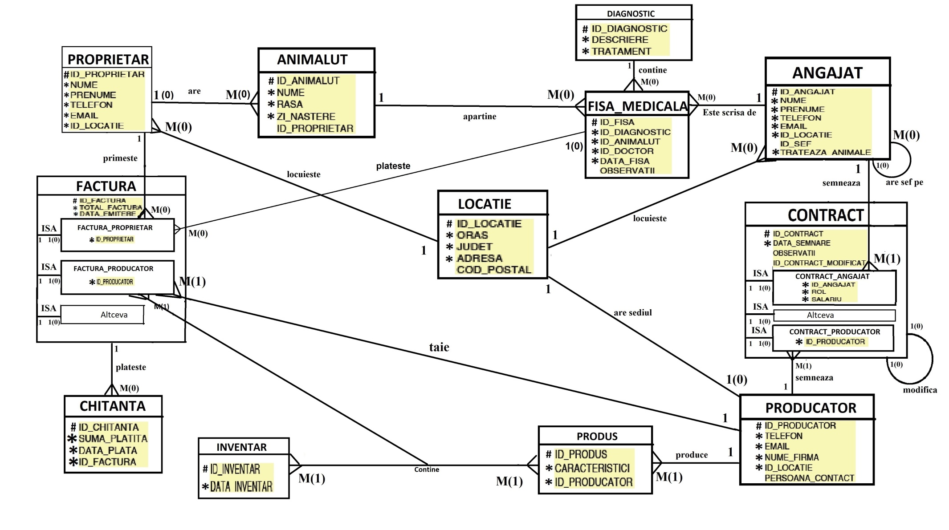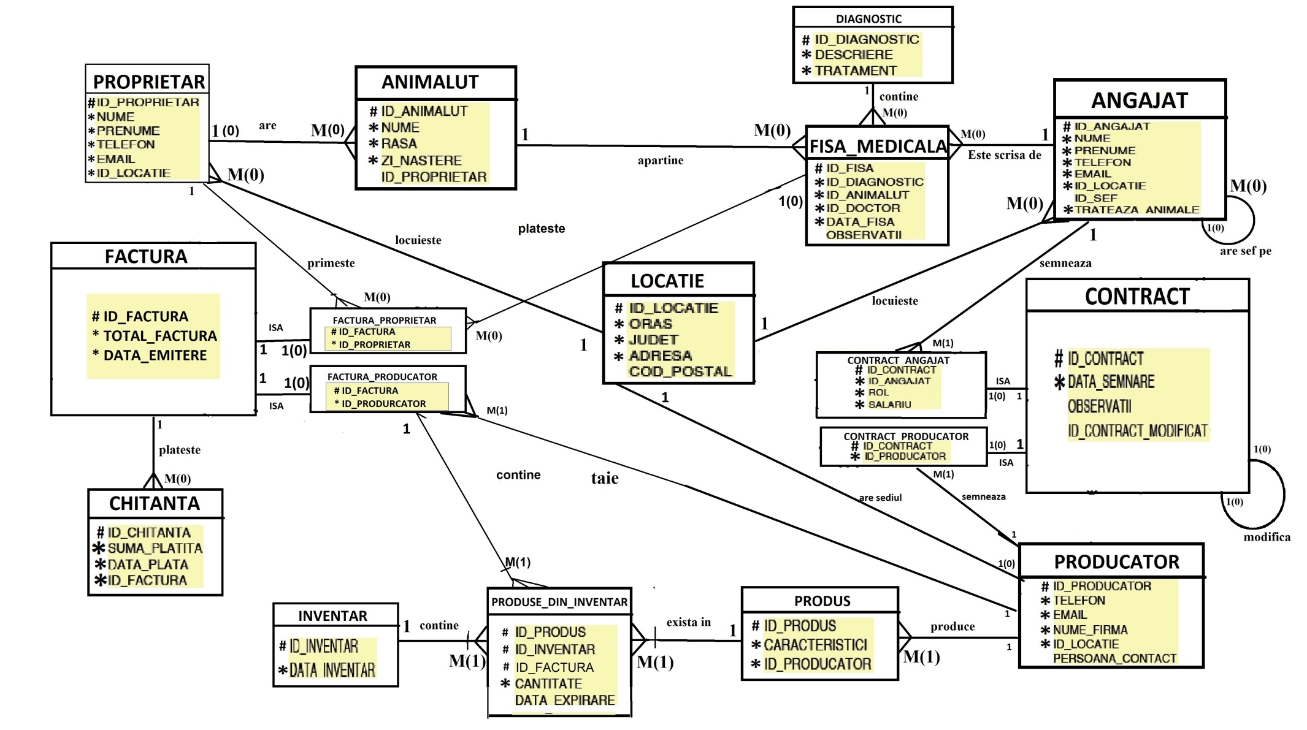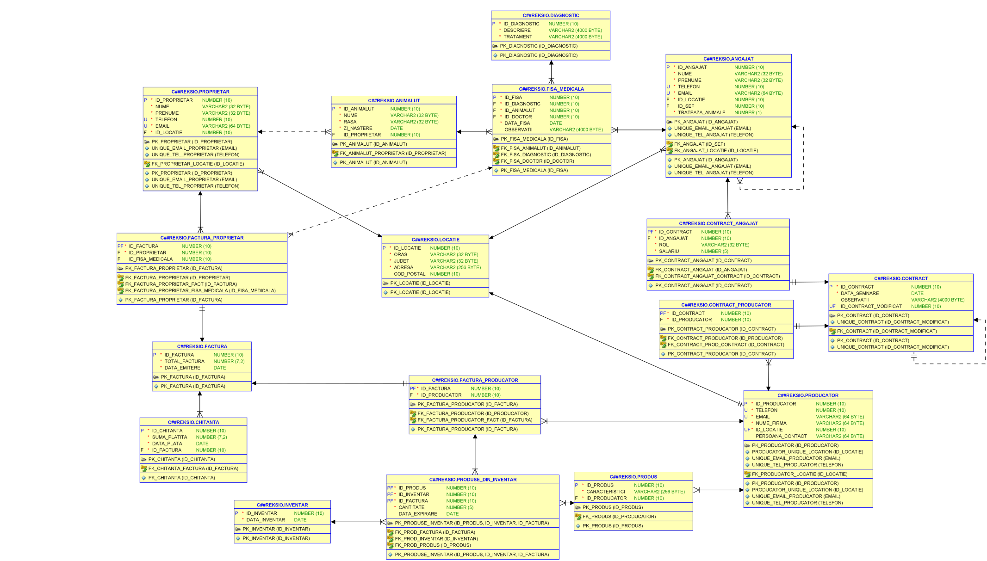

--6  
CREATE TABLE LOCATIE  
(  
 id_locatie NUMBER(10),  
 oras VARCHAR2(32) NOT NULL,  
 judet VARCHAR2(32) NOT NULL,  
 adresa VARCHAR2(256) NOT NULL,  
 cod_postal NUMBER(10),  
 CONSTRAINT pk_locatie PRIMARY KEY (id_locatie)  
);  
  
CREATE TABLE PROPRIETAR  
(  
 id_proprietar NUMBER(10),  
 nume VARCHAR2(32) NOT NULL,  
 prenume VARCHAR2(32) NOT NULL,  
 telefon NUMBER(10) NOT NULL,  
 email VARCHAR2(64) NOT NULL,  
 id_locatie NUMBER(10) NOT NULL,  
 CONSTRAINT pk_proprietar PRIMARY KEY (id_proprietar),  
 CONSTRAINT fk_proprietar_locatie FOREIGN KEY (id_locatie) REFERENCES LOCATIE (id_locatie),  
 CONSTRAINT unique_tel_proprietar UNIQUE (telefon),  
 CONSTRAINT unique_email_proprietar UNIQUE (email)  
);  
  
CREATE TABLE ANIMALUT  
(  
 id_animalut NUMBER(10),  
 nume VARCHAR2(32) NOT NULL,  
 rasa Varchar2(32) NOT NULL,  
 zi_nastere DATE NOT NULL,  
 id_proprietar NUMBER(10),  
 CONSTRAINT pk_animalut PRIMARY KEY (id_animalut),  
 CONSTRAINT fk_animalut_proprietar FOREIGN KEY (id_proprietar) REFERENCES PROPRIETAR (id_proprietar)  
);  
  
CREATE TABLE DIAGNOSTIC  
(  
 id_diagnostic NUMBER(10),  
 descriere VARCHAR2(4000) NOT NULL,  
 tratament VARCHAR2(4000) NOT NULL,  
 CONSTRAINT pk_diagnostic PRIMARY KEY (id_diagnostic)  
);  
  
CREATE TABLE ANGAJAT  
(  
 id_angajat NUMBER(10),  
 nume VARCHAR2(32) NOT NULL,  
 prenume VARCHAR2(32) NOT NULL,  
 telefon NUMBER(10) NOT NULL,  
 email VARCHAR2(64) NOT NULL,  
 id_locatie NUMBER(10) NOT NULL,  
 id_sef NUMBER(10),  
 trateaza_animale NUMBER(1) NOT NULL,  
 CONSTRAINT pk_angajat PRIMARY KEY (id_angajat),  
 CONSTRAINT fk_angajat_locatie FOREIGN KEY (id_locatie) REFERENCES LOCATIE (id_locatie),  
 CONSTRAINT fk_angajat FOREIGN KEY (id_sef) REFERENCES ANGAJAT (id_angajat),  
 CONSTRAINT unique_tel_angajat UNIQUE (telefon),  
 CONSTRAINT unique_email_angajat UNIQUE (email)  
);  
  
CREATE TABLE FISA_MEDICALA  
(  
 id_fisa NUMBER(10),  
 id_diagnostic NUMBER(10) NOT NULL,  
 id_animalut NUMBER(10) NOT NULL,  
 id_doctor NUMBER(10) NOT NULL,  
 data_fisa DATE NOT NULL,  
 observatii VARCHAR2(4000),  
 CONSTRAINT pk_fisa_medicala PRIMARY KEY (id_fisa),  
 CONSTRAINT fk_fisa_diagnostic FOREIGN KEY (id_diagnostic) REFERENCES DIAGNOSTIC (id_diagnostic),  
 CONSTRAINT fk_fisa_animalut FOREIGN KEY (id_animalut) REFERENCES ANIMALUT (id_animalut),  
 CONSTRAINT fk_fisa_doctor FOREIGN KEY (id_doctor) REFERENCES ANGAJAT (id_angajat)  
);  
  
CREATE TABLE PRODUCATOR  
(  
 id_producator NUMBER(10),  
 telefon NUMBER(10) NOT NULL,  
 email VARCHAR2(64) NOT NULL,  
 nume_firma VARCHAR2(64) NOT NULL,  
 id_locatie NUMBER(10) NOT NULL,  
 persoana_contact VARCHAR2(64),  
 CONSTRAINT pk_producator PRIMARY KEY (id_producator),  
 CONSTRAINT fk_producator_locatie FOREIGN KEY (id_locatie) REFERENCES LOCATIE (id_locatie),  
 CONSTRAINT producator_unique_location UNIQUE (id_locatie),  
 CONSTRAINT unique_tel_producator UNIQUE (telefon),  
 CONSTRAINT unique_email_producator UNIQUE (email)  
);  
  
CREATE TABLE CONTRACT  
(  
 id_contract NUMBER(10),  
 data_semnare DATE NOT NULL,  
 observatii VARCHAR2(4000),  
 id_contract_modificat NUMBER(10),  
 CONSTRAINT pk_contract PRIMARY KEY (id_contract),  
 CONSTRAINT fk_contract FOREIGN KEY (id_contract_modificat) REFERENCES CONTRACT (id_contract),  
 CONSTRAINT unique_contract UNIQUE (id_contract_modificat)  
);  
  
CREATE TABLE CONTRACT_ANGAJAT  
(  
 id_contract NUMBER(10),  
 id_angajat NUMBER(10) NOT NULL,  
 rol VARCHAR2(32) NOT NULL,  
 salariu NUMBER(5) NOT NULL,  
 CONSTRAINT pk_contract_angajat PRIMARY KEY (id_contract),  
 CONSTRAINT fk_contract_angajat_contract FOREIGN KEY (id_contract) REFERENCES CONTRACT (id_contract),  
 CONSTRAINT fk_contract_angajat FOREIGN KEY (id_angajat) REFERENCES ANGAJAT (id_angajat)  
);  
  
CREATE TABLE CONTRACT_PRODUCATOR  
(  
 id_contract NUMBER(10),  
 id_producator NUMBER(10) NOT NULL,  
 CONSTRAINT pk_contract_producator PRIMARY KEY (id_contract),  
 CONSTRAINT fk_contract_prod_contract FOREIGN KEY (id_contract) REFERENCES CONTRACT (id_contract),  
 CONSTRAINT fk_contract_producator FOREIGN KEY (id_producator) REFERENCES PRODUCATOR (id_producator)  
);  
  
CREATE TABLE FACTURA  
(  
 id_factura NUMBER(10),  
 total_factura NUMBER(7, 2) NOT NULL,  
 data_emitere DATE NOT NULL,  
 CONSTRAINT pk_factura PRIMARY KEY (id_factura)  
);  
  
CREATE TABLE FACTURA_PROPRIETAR  
(  
 id_factura NUMBER(10),  
 id_proprietar NUMBER(10) NOT NULL,  
 id_fisa_medicala NUMBER(10),  
 CONSTRAINT pk_factura_proprietar PRIMARY KEY (id_factura),  
 CONSTRAINT fk_factura_proprietar FOREIGN KEY (id_proprietar) REFERENCES PROPRIETAR (id_proprietar),  
 CONSTRAINT fk_factura_proprietar_fact FOREIGN KEY (id_factura) REFERENCES FACTURA (id_factura),  
 CONSTRAINT fk_factura_proprietar_fisa_medicala FOREIGN KEY (id_fisa_medicala) REFERENCES FISA_MEDICALA (id_fisa)  
);  
  
CREATE TABLE FACTURA_PRODUCATOR  
(  
 id_factura NUMBER(10),  
 id_producator NUMBER(10) NOT NULL,  
 CONSTRAINT pk_factura_producator PRIMARY KEY (id_factura),  
 CONSTRAINT fk_factura_producator FOREIGN KEY (id_producator) REFERENCES PRODUCATOR (id_producator),  
 CONSTRAINT fk_factura_producator_fact FOREIGN KEY (id_factura) REFERENCES FACTURA (id_factura)  
);  
  
CREATE TABLE CHITANTA  
(  
 id_chitanta NUMBER(10),  
 suma_platita NUMBER(7, 2) NOT NULL,  
 data_plata DATE NOT NULL,  
 id_factura NUMBER(10) NOT NULL,  
 CONSTRAINT pk_chitanta PRIMARY KEY (id_chitanta),  
 CONSTRAINT fk_chitanta_factura FOREIGN KEY (id_factura) references FACTURA (id_factura)  
);  
  
  
CREATE TABLE PRODUS  
(  
 id_produs NUMBER(10),  
 caracteristici VARCHAR2(256) NOT NULL,  
 id_producator NUMBER(10) NOT NULL,  
 CONSTRAINT pk_produs PRIMARY KEY (id_produs),  
 CONSTRAINT fk_produs FOREIGN KEY (id_producator) REFERENCES PRODUCATOR (id_producator)  
);  
  
CREATE TABLE INVENTAR  
(  
 id_inventar NUMBER(10),  
 data_inventar DATE NOT NULL,  
 CONSTRAINT pk_inventar PRIMARY KEY (id_inventar)  
);  
  
CREATE TABLE PRODUSE_DIN_INVENTAR  
(  
 id_produs NUMBER(10) NOT NULL,  
 id_inventar NUMBER(10) NOT NULL,  
 id_factura NUMBER(10) NOT NULL,  
 cantitate NUMBER(5) NOT NULL,  
 data_expirare DATE,  
 CONSTRAINT pk_produse_inventar PRIMARY KEY (id_produs, id_inventar, id_factura),  
 CONSTRAINT fk_prod_inventar FOREIGN KEY (id_inventar) REFERENCES INVENTAR (id_inventar),  
 CONSTRAINT fk_prod_produs FOREIGN KEY (id_produs) REFERENCES PRODUS (id_produs),  
 CONSTRAINT fk_prod_factura FOREIGN KEY (id_factura) REFERENCES FACTURA_PRODUCATOR (id_factura)  
);  
  
commit;

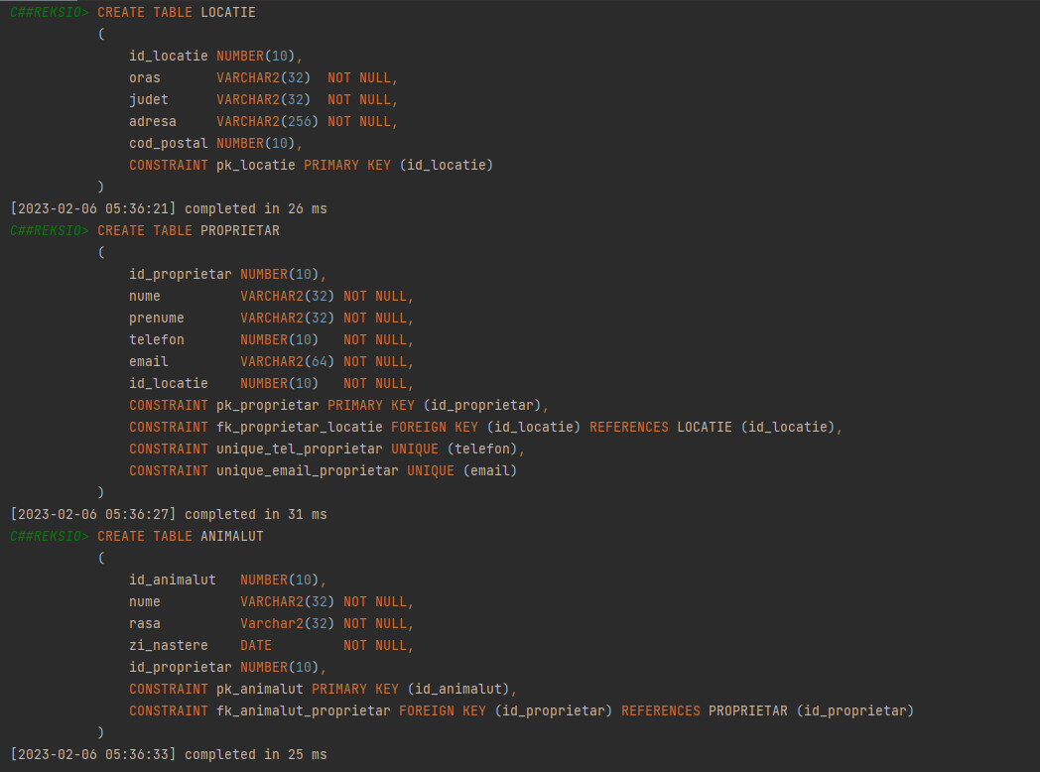

--5  
INSERT INTO LOCATIE(id_locatie, oras, judet, adresa)  
VALUES (1, 'Bucuresti', 'Sector 2', 'soseaua colentina nr 2');  
INSERT INTO LOCATIE(id_locatie, oras, judet, adresa, cod_postal)  
VALUES (2, 'Bucuresti', 'Sector 1', 'soseaua Aviatorilor nr 1', 12345);  
INSERT INTO LOCATIE(id_locatie, oras, judet, adresa)  
VALUES (3, 'Pantelimon', 'Ilfov', 'soseaua dn2');  
INSERT INTO LOCATIE(id_locatie, oras, judet, adresa)  
VALUES (4, 'Cluj-Napoca', 'Cluj', 'soseaua jmekera');  
INSERT INTO LOCATIE(id_locatie, oras, judet, adresa)  
VALUES (5, 'Iasi', 'Iasi', 'soseaua industriei');  
INSERT INTO LOCATIE(id_locatie, oras, judet, adresa)  
VALUES (6, 'Timisoara', 'Timis', 'soseaua intreprinderii');  
INSERT INTO LOCATIE(id_locatie, oras, judet, adresa)  
VALUES (7, 'Constanta', 'Constanta', 'soseaua antreprenorilor');  
INSERT INTO LOCATIE(id_locatie, oras, judet, adresa)  
VALUES (8, 'Giurgiu', 'Giurgiu', 'soseaua giurgiului');  
INSERT INTO LOCATIE(id_locatie, oras, judet, adresa)  
VALUES (9, 'Severin', 'Mehedinti', 'traian');  
  
INSERT INTO PROPRIETAR(id_proprietar, nume, prenume, email, telefon, id_locatie)  
VALUES (1, 'Staicu', 'Octavian-Florin', 'octavian.staicu@s.unibuc.ro', 0736659442, 1);  
INSERT INTO PROPRIETAR(id_proprietar, nume, prenume, email, telefon, id_locatie)  
VALUES (2, 'Bodea', 'George', 'george@yahoo.com', 0737392518, 2);  
INSERT INTO PROPRIETAR(id_proprietar, nume, prenume, email, telefon, id_locatie)  
VALUES (3, 'Staicu', 'Adrian', 'adi@gmail.com', 0736659441, 1);  
INSERT INTO PROPRIETAR(id_proprietar, nume, prenume, email, telefon, id_locatie)  
VALUES (4, 'Popescu', 'Ion', 'popescu.ion@gmail.com', 0771654789, 3);  
INSERT INTO PROPRIETAR(id_proprietar, nume, prenume, email, telefon, id_locatie)  
VALUES (5, 'Cineva', 'Interesant', 'jmekerie@my.fmi.unibuc.ro', 0777111999, 4);  
INSERT INTO PROPRIETAR(id_proprietar, nume, prenume, email, telefon, id_locatie)  
VALUES (6, 'Fara', 'Animalut', 'cumparator@my.fmi.unibuc.ro', 0729123123, 2);  
  
INSERT INTO ANIMALUT(id_animalut, nume, rasa, zi_nastere, id_proprietar)  
VALUES (1, 'Bit', 'Boxer', *to_date*('05/05/2017', 'DD/MM/YYYY'), 1);  
INSERT INTO ANIMALUT(id_animalut, nume, rasa, zi_nastere, id_proprietar)  
VALUES (2, 'Kid', 'Ciobanesc German', *to_date*('13/07/2010', 'DD/MM/YYYY'), 3);  
INSERT INTO ANIMALUT(id_animalut, nume, rasa, zi_nastere, id_proprietar)  
VALUES (3, 'Kitty', 'Birmaneza', *to_date*('25/12/2015', 'DD/MM/YYYY'), 2);  
INSERT INTO ANIMALUT(id_animalut, nume, rasa, zi_nastere, id_proprietar)  
VALUES (4, 'Angelina', 'Pisica Tigrata de Hymalaia', *to_date*('06/06/2016', 'DD/MM/YYYY'), 5);  
INSERT INTO ANIMALUT(id_animalut, nume, rasa, zi_nastere, id_proprietar)  
VALUES (5, 'John', 'Metis', *to_date*('05/12/2008', 'DD/MM/YYYY'), 4);  
insert into ANIMALUT(id_animalut, nume, rasa, zi_nastere, id_proprietar)  
VALUES (6, 'dog', 'Boxer', *to_date*('09.01.2021', 'dd.mm.yyyy'), 5);  
insert into ANIMALUT(id_animalut, nume, rasa, zi_nastere, id_proprietar)  
VALUES (13, 'Thor', 'Golden Retriever', *to_date*('13.07.2020', 'dd.mm.yyyy'), 1);  
insert into ANIMALUT(id_animalut, nume, rasa, zi_nastere)  
VALUES (11, 'Idk', 'Comuna', *to_date*('13.01.2023', 'dd.mm.yyyy'));  
insert into ANIMALUT(id_animalut, nume, rasa, zi_nastere)  
VALUES (14, 'Idk2', 'Comuna', *to_date*('01.02.2023', 'dd.mm.yyyy'));  
  
INSERT INTO DIAGNOSTIC(id_diagnostic, descriere, tratament)  
VALUES (1, 'Vaccinare Leptospiroza', 'Vaccin Leptospiroza');  
INSERT INTO DIAGNOSTIC(id_diagnostic, descriere, tratament)  
VALUES (2, 'Enterocolita', 'Enteroguarg');  
INSERT INTO DIAGNOSTIC(id_diagnostic, descriere, tratament)  
VALUES (3, 'Rana deschisa', 'Spray Cicatrizant');  
INSERT INTO DIAGNOSTIC(id_diagnostic, descriere, tratament)  
VALUES (4, 'durere abdominala', 'ecografie');  
INSERT INTO DIAGNOSTIC(id_diagnostic, descriere, tratament)  
VALUES (5, 'capusa', 'eliminare capusa');  
  
INSERT INTO ANGAJAT(id_angajat, nume, prenume, telefon, email, id_locatie, trateaza_animale)  
VALUES (1, 'Staicu', 'Clara', 0722012983, 'dr.staicu-clara@clinicatareanimale.ro', 1, 1);  
INSERT INTO ANGAJAT(id_angajat, nume, prenume, telefon, email, id_sef, id_locatie, trateaza_animale)  
VALUES (2, 'Popa', 'Adi', 0723145867, 'asistent.popa-adi@clinicatareanimale.ro', 1, 2, 1);  
INSERT INTO ANGAJAT(id_angajat, nume, prenume, telefon, email, id_locatie, trateaza_animale)  
VALUES (3, 'Spalatorul', 'Pop', 0711012070, 'spalatorul.pop@gmail.com', 3, 0);  
INSERT INTO ANGAJAT(id_angajat, nume, prenume, telefon, email, id_locatie, trateaza_animale)  
VALUES (4, 'Ana', 'Maria', 0723012982, 'dr.ana-maria@clinicatareanimale.ro', 1, 1);  
INSERT INTO ANGAJAT(id_angajat, nume, prenume, telefon, email, id_sef, id_locatie, trateaza_animale)  
VALUES (5, 'Numinescu', 'George', 0723145868, 'asistent.numinescu-george@clinicatareanimale.ro', 4, 2, 1);  
  
INSERT INTO FISA_MEDICALA(id_fisa, id_diagnostic, id_animalut, id_doctor, data_fisa, observatii)  
VALUES (1, 2, 1, 1, *to_date*('13.07.2020', 'dd.mm.yyyy'), 'Stapanul a dat caineul sa manance tort');  
INSERT INTO FISA_MEDICALA(id_fisa, id_diagnostic, id_animalut, id_doctor, data_fisa)  
VALUES (2, 1, 2, 1, *to_date*('13.07.2011', 'dd.mm.yyyy'));  
INSERT INTO FISA_MEDICALA(id_fisa, id_diagnostic, id_animalut, id_doctor, data_fisa)  
VALUES (3, 1, 3, 2, *to_date*('13.07.2016', 'dd.mm.yyyy'));  
INSERT INTO FISA_MEDICALA(id_fisa, id_diagnostic, id_animalut, id_doctor, data_fisa, observatii)  
VALUES (4, 3, 1, 2, *to_date*('13.09.2020', 'dd.mm.yyyy'), 'Rana deschisa in zona botului');  
INSERT INTO FISA_MEDICALA(id_fisa, id_diagnostic, id_animalut, id_doctor, data_fisa, observatii)  
VALUES (5, 1, 4, 1, *to_date*('13.07.2017', 'dd.mm.yyyy'), 'Una din cele mai frumoase specimene');  
INSERT INTO FISA_MEDICALA(id_fisa, id_diagnostic, id_animalut, id_doctor, data_fisa)  
VALUES (6, 2, 5, 1, *to_date*('04.05.2009', 'dd.mm.yyyy'));  
INSERT INTO FISA_MEDICALA(id_fisa, id_diagnostic, id_animalut, id_doctor, data_fisa, observatii)  
VALUES (7, 1, 5, 2, *to_date*('14.06.2010', 'dd.mm.yyyy'), 'Vaccinare anuala');  
INSERT INTO FISA_MEDICALA(id_fisa, id_diagnostic, id_animalut, id_doctor, data_fisa)  
VALUES (8, 1, 4, 2, *to_date*('13.07.2020', 'dd.mm.yyyy'));  
INSERT INTO FISA_MEDICALA(id_fisa, id_diagnostic, id_animalut, id_doctor, data_fisa, observatii)  
VALUES (9, 3, 3, 1, *to_date*('13.12.2016', 'dd.mm.yyyy'), 'S-a taiat intr-o conserva de peste');  
INSERT INTO FISA_MEDICALA(id_fisa, id_diagnostic, id_animalut, id_doctor, data_fisa, observatii)  
VALUES (10, 2, 1, 1, *to_date*('25.12.2020', 'dd.mm.yyyy'), 'Cainele a mancat din pregaritile de Craciun');  
INSERT INTO FISA_MEDICALA(id_fisa, id_diagnostic, id_animalut, id_doctor, data_fisa)  
VALUES (11, 3, 5, 1, *to_date*('14.08.2015', 'dd.mm.yyyy'));  
insert into FISA_MEDICALA(id_fisa, id_diagnostic, id_animalut, id_doctor, data_fisa)  
VALUES (13, 1, 13, 1, *to_date*('13.09.2020', 'dd.mm.yyyy'));  
insert into FISA_MEDICALA(id_fisa, id_diagnostic, id_animalut, id_doctor, data_fisa)  
VALUES (12, 1, 13, 1, *to_date*('13.07.2021', 'dd.mm.yyyy'));  
INSERT INTO FISA_MEDICALA(id_fisa, id_diagnostic, id_animalut, id_doctor, data_fisa, observatii)  
VALUES (14, 3, 11, 1, *to_date*('05.02.2023', 'dd.mm.yyyy'), 'catelus fara stapan');  
INSERT INTO FISA_MEDICALA(id_fisa, id_diagnostic, id_animalut, id_doctor, data_fisa, observatii)  
VALUES (15, 3, 14, 1, *to_date*('05.02.2023', 'dd.mm.yyyy'), 'catelus fara stapan');  
  
INSERT INTO PRODUCATOR(id_producator, nume_firma, telefon, email, id_locatie)  
VALUES (1, 'Mancare Catei SA', 0767582563, 'comenzi@mancarecatei.ro', 5);  
INSERT INTO PRODUCATOR(id_producator, nume_firma, telefon, email, persoana_contact, id_locatie)  
VALUES (2, 'Aparatura Animale SRL', 0798712365, 'aparatus.ion@aparaturaanimale.ro', 'Aparatus Ion', 6);  
INSERT INTO PRODUCATOR(id_producator, nume_firma, telefon, email, persoana_contact, id_locatie)  
VALUES (3, 'Vaccinam cu Iubire', 0712345678, 'bussines@vacciniubire.ro', 'Ana Vacix', 7);  
INSERT INTO PRODUCATOR(id_producator, nume_firma, telefon, email, persoana_contact, id_locatie)  
VALUES (4, 'Producator 4', 0700000000, 'producator4@bussines.ro', 'Producator 4 contact', 8);  
INSERT INTO PRODUCATOR(id_producator, nume_firma, telefon, email, persoana_contact, id_locatie)  
VALUES (5, 'Producator 5', 0711111111, 'bussines@producator5.ro', 'contact prod 5', 9);  
  
INSERT INTO CONTRACT(id_contract, data_semnare)  
VALUES (1, *to_date*('02.01.2005', 'dd.mm.yyyy'));  
INSERT INTO CONTRACT(id_contract, data_semnare)  
VALUES (2, *to_date*('13.07.2004', 'dd.mm.yyyy'));  
INSERT INTO CONTRACT(id_contract, data_semnare)  
VALUES (3, *to_date*('09.09.2005', 'dd.mm.yyyy'));  
INSERT INTO CONTRACT(id_contract, data_semnare)  
VALUES (4, *to_date*('01.05.2007', 'dd.mm.yyyy'));  
INSERT INTO CONTRACT(id_contract, data_semnare)  
VALUES (5, *to_date*('02.06.2008', 'dd.mm.yyyy'));  
INSERT INTO CONTRACT(id_contract, data_semnare)  
VALUES (6, *to_date*('02.01.2005', 'dd.mm.yyyy'));  
INSERT INTO CONTRACT(id_contract, data_semnare, observatii, id_contract_modificat)  
VALUES (7, *to_date*('28.12.2020', 'dd.mm.yyyy'), 'Promovare', 2);  
INSERT INTO CONTRACT(id_contract, data_semnare)  
VALUES (8, *to_date*('02.01.2020', 'dd.mm.yyyy'));  
INSERT INTO CONTRACT(id_contract, data_semnare)  
VALUES (9, *to_date*('02.01.2021', 'dd.mm.yyyy'));  
INSERT INTO CONTRACT(id_contract, data_semnare)  
VALUES (10, *to_date*('02.07.2022', 'dd.mm.yyyy'));  
INSERT INTO CONTRACT(id_contract, data_semnare)  
VALUES (11, *to_date*('13.01.2023', 'dd.mm.yyyy'));  
  
INSERT INTO CONTRACT_ANGAJAT(id_contract, id_angajat, rol, salariu)  
VALUES (1, 1, 'doctor veterinar', 6000);  
INSERT INTO CONTRACT_ANGAJAT(id_contract, id_angajat, rol, salariu)  
VALUES (2, 2, 'asistent veterinar', 3000);  
INSERT INTO CONTRACT_ANGAJAT(id_contract, id_angajat, rol, salariu)  
VALUES (3, 3, 'paznic', 1500);  
INSERT INTO CONTRACT_ANGAJAT(id_contract, id_angajat, rol, salariu)  
VALUES (7, 2, 'doctor veterinar', 6000);  
INSERT INTO CONTRACT_ANGAJAT(id_contract, id_angajat, rol, salariu)  
VALUES (8, 4, 'doctor veterinar', 6000);  
INSERT INTO CONTRACT_ANGAJAT(id_contract, id_angajat, rol, salariu)  
VALUES (9, 5, 'asistent veterinar', 3000);  
  
INSERT INTO CONTRACT_PRODUCATOR(id_contract, id_producator)  
VALUES (4, 1);  
INSERT INTO CONTRACT_PRODUCATOR(id_contract, id_producator)  
VALUES (5, 2);  
INSERT INTO CONTRACT_PRODUCATOR(id_contract, id_producator)  
VALUES (6, 3);  
INSERT INTO CONTRACT_PRODUCATOR(id_contract, id_producator)  
VALUES (10, 4);  
INSERT INTO CONTRACT_PRODUCATOR(id_contract, id_producator)  
VALUES (11, 5);  
  
INSERT INTO FACTURA(ID_FACTURA, TOTAL_FACTURA, DATA_EMITERE)  
VALUES (1, 300, *to_date*('13.07.2020', 'dd.mm.yyyy'));  
INSERT INTO FACTURA(ID_FACTURA, TOTAL_FACTURA, DATA_EMITERE)  
VALUES (2, 300, *to_date*('13.07.2011', 'dd.mm.yyyy'));  
INSERT INTO FACTURA(ID_FACTURA, TOTAL_FACTURA, DATA_EMITERE)  
VALUES (3, 300, *to_date*('13.07.2015', 'dd.mm.yyyy'));  
INSERT INTO FACTURA(ID_FACTURA, TOTAL_FACTURA, DATA_EMITERE)  
VALUES (4, 300, *to_date*('13.09.2020', 'dd.mm.yyyy'));  
INSERT INTO FACTURA(ID_FACTURA, TOTAL_FACTURA, DATA_EMITERE)  
VALUES (5, 300, *to_date*('13.07.2017', 'dd.mm.yyyy'));  
INSERT INTO FACTURA(ID_FACTURA, TOTAL_FACTURA, DATA_EMITERE)  
VALUES (6, 300, *to_date*('04.05.2009', 'dd.mm.yyyy'));  
INSERT INTO FACTURA(ID_FACTURA, TOTAL_FACTURA, DATA_EMITERE)  
VALUES (7, 300, *to_date*('14.06.2010', 'dd.mm.yyyy'));  
INSERT INTO FACTURA(ID_FACTURA, TOTAL_FACTURA, DATA_EMITERE)  
VALUES (8, 300, *to_date*('13.07.2020', 'dd.mm.yyyy'));  
INSERT INTO FACTURA(ID_FACTURA, TOTAL_FACTURA, DATA_EMITERE)  
VALUES (9, 300, *to_date*('13.12.2016', 'dd.mm.yyyy'));  
INSERT INTO FACTURA(ID_FACTURA, TOTAL_FACTURA, DATA_EMITERE)  
VALUES (10, 300, *to_date*('25.12.2020', 'dd.mm.yyyy'));  
insert into FACTURA(id_factura, total_factura, data_emitere)  
VALUES (104, 300, *to_date*('13.07.2021', 'dd.mm.yyyy'));  
insert into FACTURA(id_factura, total_factura, data_emitere)  
VALUES (105, 3000, *to_date*('13.07.2021', 'dd.mm.yyyy'));  
insert into FACTURA(id_factura, total_factura, data_emitere)  
VALUES (106, 3000, *to_date*('12.05.2021', 'dd.mm.yyyy'));  
insert into FACTURA(id_factura, total_factura, data_emitere)  
VALUES (107, 3000, *to_date*('12.05.2021', 'dd.mm.yyyy'));  
Insert into FACTURA(id_factura, total_factura, data_emitere)  
VALUES (1000, 100, *sysdate*);  
Insert into FACTURA(id_factura, total_factura, data_emitere)  
VALUES (1001, 100, *sysdate*);  
Insert into FACTURA(id_factura, total_factura, data_emitere)  
VALUES (1002, 499, *to_date*('06.02.2023', 'dd.mm.yyyy'));  
INSERT INTO FACTURA(ID_FACTURA, TOTAL_FACTURA, DATA_EMITERE)  
VALUES (11, 1500, *to_date*('25.10.2009', 'dd.mm.yyyy'));  
INSERT INTO FACTURA(ID_FACTURA, TOTAL_FACTURA, DATA_EMITERE)  
VALUES (12, 4325, *to_date*('13.11.2009', 'dd.mm.yyyy'));  
INSERT INTO FACTURA(ID_FACTURA, TOTAL_FACTURA, DATA_EMITERE)  
VALUES (13, 6000, *to_date*('25.07.2009', 'dd.mm.yyyy'));  
INSERT INTO FACTURA(ID_FACTURA, TOTAL_FACTURA, DATA_EMITERE)  
VALUES (14, 1400, *to_date*('25.10.2014', 'dd.mm.yyyy'));  
INSERT INTO FACTURA(ID_FACTURA, TOTAL_FACTURA, DATA_EMITERE)  
VALUES (15, 4725, *to_date*('13.04.2013', 'dd.mm.yyyy'));  
INSERT INTO FACTURA(ID_FACTURA, TOTAL_FACTURA, DATA_EMITERE)  
VALUES (16, 6025, *to_date*('25.09.2014', 'dd.mm.yyyy'));  
INSERT INTO FACTURA(ID_FACTURA, TOTAL_FACTURA, DATA_EMITERE)  
VALUES (17, 5000, *to_date*('13.11.2019', 'dd.mm.yyyy'));  
INSERT INTO FACTURA(ID_FACTURA, TOTAL_FACTURA, DATA_EMITERE)  
VALUES (18, 7500, *to_date*('25.09.2019', 'dd.mm.yyyy'));  
INSERT INTO FACTURA(ID_FACTURA, TOTAL_FACTURA, DATA_EMITERE)  
VALUES (19, 9256.35, *to_date*('12.04.2019', 'dd.mm.yyyy'));  
  
INSERT INTO FACTURA_PROPRIETAR(id_factura, id_proprietar, id_fisa_medicala)  
VALUES (1, 1, 1);  
INSERT INTO FACTURA_PROPRIETAR(id_factura, id_proprietar, id_fisa_medicala)  
VALUES (2, 3, 2);  
INSERT INTO FACTURA_PROPRIETAR(id_factura, id_proprietar, id_fisa_medicala)  
VALUES (3, 2, 3);  
INSERT INTO FACTURA_PROPRIETAR(id_factura, id_proprietar, id_fisa_medicala)  
VALUES (4, 1, 4);  
INSERT INTO FACTURA_PROPRIETAR(id_factura, id_proprietar, id_fisa_medicala)  
VALUES (5, 5, 5);  
INSERT INTO FACTURA_PROPRIETAR(id_factura, id_proprietar, id_fisa_medicala)  
VALUES (6, 4, 6);  
INSERT INTO FACTURA_PROPRIETAR(id_factura, id_proprietar, id_fisa_medicala)  
VALUES (7, 4, 7);  
INSERT INTO FACTURA_PROPRIETAR(id_factura, id_proprietar, id_fisa_medicala)  
VALUES (8, 5, 8);  
INSERT INTO FACTURA_PROPRIETAR(id_factura, id_proprietar, id_fisa_medicala)  
VALUES (9, 2, 9);  
INSERT INTO FACTURA_PROPRIETAR(id_factura, id_proprietar, id_fisa_medicala)  
VALUES (10, 1, 10);  
INSERT INTO FACTURA_PROPRIETAR(id_factura, id_proprietar, id_fisa_medicala)  
VALUES (104, 1, 11);  
INSERT INTO FACTURA_PROPRIETAR(id_factura, id_proprietar, id_fisa_medicala)  
VALUES (105, 1, 12);  
INSERT INTO FACTURA_PROPRIETAR(id_factura, id_proprietar, id_fisa_medicala)  
VALUES (106, 2, 13);  
INSERT INTO FACTURA_PROPRIETAR(id_factura, id_proprietar, id_fisa_medicala)  
VALUES (107, 2, 13);  
INSERT INTO FACTURA_PROPRIETAR(id_factura, id_proprietar)  
VALUES (1000, 5);  
INSERT INTO FACTURA_PROPRIETAR(id_factura, id_proprietar, id_fisa_medicala)  
VALUES (1002, 5, 15);  
  
INSERT INTO FACTURA_PRODUCATOR(id_factura, id_producator)  
VALUES (11, 1);  
INSERT INTO FACTURA_PRODUCATOR(id_factura, id_producator)  
VALUES (12, 2);  
INSERT INTO FACTURA_PRODUCATOR(id_factura, id_producator)  
VALUES (13, 3);  
INSERT INTO FACTURA_PRODUCATOR(id_factura, id_producator)  
VALUES (14, 1);  
INSERT INTO FACTURA_PRODUCATOR(id_factura, id_producator)  
VALUES (15, 2);  
INSERT INTO FACTURA_PRODUCATOR(id_factura, id_producator)  
VALUES (16, 3);  
INSERT INTO FACTURA_PRODUCATOR(id_factura, id_producator)  
VALUES (17, 1);  
INSERT INTO FACTURA_PRODUCATOR(id_factura, id_producator)  
VALUES (18, 2);  
INSERT INTO FACTURA_PRODUCATOR(id_factura, id_producator)  
VALUES (19, 3);  
  
INSERT INTO CHITANTA(id_chitanta, suma_platita, data_plata, id_factura)  
VALUES (1, 150, *to_date*('13.07.2020', 'dd.mm.yyyy'), 1);  
INSERT INTO CHITANTA(id_chitanta, suma_platita, data_plata, id_factura)  
VALUES (2, 300, *to_date*('13.07.2011', 'dd.mm.yyyy'), 2);  
INSERT INTO CHITANTA(id_chitanta, suma_platita, data_plata, id_factura)  
VALUES (3, 300, *to_date*('13.08.2015', 'dd.mm.yyyy'), 3);  
INSERT INTO CHITANTA(id_chitanta, suma_platita, data_plata, id_factura)  
VALUES (4, 300, *to_date*('03.01.2021', 'dd.mm.yyyy'), 4);  
INSERT INTO CHITANTA(id_chitanta, suma_platita, data_plata, id_factura)  
VALUES (5, 150, *to_date*('13.07.2017', 'dd.mm.yyyy'), 5);  
INSERT INTO CHITANTA(id_chitanta, suma_platita, data_plata, id_factura)  
VALUES (6, 75.25, *to_date*('13.08.2017', 'dd.mm.yyyy'), 5);  
INSERT INTO CHITANTA(id_chitanta, suma_platita, data_plata, id_factura)  
VALUES (7, 75.75, *to_date*('13.09.2017', 'dd.mm.yyyy'), 5);  
INSERT INTO CHITANTA(id_chitanta, suma_platita, data_plata, id_factura)  
VALUES (8, 100, *to_date*('13.07.2009', 'dd.mm.yyyy'), 6);  
INSERT INTO CHITANTA(id_chitanta, suma_platita, data_plata, id_factura)  
VALUES (9, 200, *to_date*('17.08.2009', 'dd.mm.yyyy'), 6);  
INSERT INTO CHITANTA(id_chitanta, suma_platita, data_plata, id_factura)  
VALUES (10, 300, *to_date*('13.07.2010', 'dd.mm.yyyy'), 7);  
INSERT INTO CHITANTA(id_chitanta, suma_platita, data_plata, id_factura)  
VALUES (11, 300, *to_date*('13.09.2020', 'dd.mm.yyyy'), 8);  
INSERT INTO CHITANTA(id_chitanta, suma_platita, data_plata, id_factura)  
VALUES (12, 300, *to_date*('13.12.2016', 'dd.mm.yyyy'), 9);  
INSERT INTO CHITANTA(id_chitanta, suma_platita, data_plata, id_factura)  
VALUES (13, 300, *to_date*('15.01.2021', 'dd.mm.yyyy'), 10);  
INSERT INTO CHITANTA(id_chitanta, suma_platita, data_plata, id_factura)  
VALUES (14, 1500, *to_date*('25.10.2009', 'dd.mm.yyyy'), 11);  
INSERT INTO CHITANTA(id_chitanta, suma_platita, data_plata, id_factura)  
VALUES (15, 4325, *to_date*('25.10.2009', 'dd.mm.yyyy'), 12);  
INSERT INTO CHITANTA(id_chitanta, suma_platita, data_plata, id_factura)  
VALUES (16, 3000, *to_date*('25.07.2009', 'dd.mm.yyyy'), 13);  
INSERT INTO CHITANTA(id_chitanta, suma_platita, data_plata, id_factura)  
VALUES (17, 3000, *to_date*('25.09.2009', 'dd.mm.yyyy'), 13);  
INSERT INTO CHITANTA(id_chitanta, suma_platita, data_plata, id_factura)  
VALUES (18, 1400, *to_date*('25.10.2014', 'dd.mm.yyyy'), 14);  
INSERT INTO CHITANTA(id_chitanta, suma_platita, data_plata, id_factura)  
VALUES (19, 4725, *to_date*('13.05.2013', 'dd.mm.yyyy'), 15);  
INSERT INTO CHITANTA(id_chitanta, suma_platita, data_plata, id_factura)  
VALUES (20, 3025, *to_date*('25.09.2014', 'dd.mm.yyyy'), 16);  
INSERT INTO CHITANTA(id_chitanta, suma_platita, data_plata, id_factura)  
VALUES (21, 3000, *to_date*('01.11.2014', 'dd.mm.yyyy'), 16);  
INSERT INTO CHITANTA(id_chitanta, suma_platita, data_plata, id_factura)  
VALUES (22, 4500, *to_date*('25.10.2019', 'dd.mm.yyyy'), 18);  
insert into CHITANTA(id_chitanta, suma_platita, data_plata, id_factura)  
VALUES (104, 300, *to_date*('13.07.2021', 'dd.mm.yyyy'), 104);  
insert into CHITANTA(id_chitanta, suma_platita, data_plata, id_factura)  
VALUES (106, 600, *to_date*('13.07.2021', 'dd.mm.yyyy'), 106);  
  
  
INSERT INTO PRODUS(id_produs, caracteristici, id_producator)  
VALUES (1, 'boabe de caini cu carne de vita si somon', 1);  
INSERT INTO PRODUS(id_produs, caracteristici, id_producator)  
VALUES (2, 'boabe de pisici cu ulei de peste', 1);  
INSERT INTO PRODUS(id_produs, caracteristici, id_producator)  
VALUES (3, 'aparat radiografie', 2);  
INSERT INTO PRODUS(id_produs, caracteristici, id_producator)  
VALUES (4, 'stetoscop', 2);  
INSERT INTO PRODUS(id_produs, caracteristici, id_producator)  
VALUES (5, 'masa operatii', 2);  
INSERT INTO PRODUS(id_produs, caracteristici, id_producator)  
VALUES (6, 'vaccin leptospiroza', 3);  
INSERT INTO PRODUS(id_produs, caracteristici, id_producator)  
VALUES (7, 'vaccin hexavalent', 3);  
  
INSERT INTO INVENTAR(id_inventar, data_inventar)  
VALUES (1, *to_date*('05.01.2010', 'dd.mm.yyyy'));  
INSERT INTO INVENTAR(id_inventar, data_inventar)  
VALUES (2, *to_date*('05.01.2015', 'dd.mm.yyyy'));  
INSERT INTO INVENTAR(id_inventar, data_inventar)  
VALUES (3, *to_date*('05.01.2020', 'dd.mm.yyyy'));  
INSERT INTO INVENTAR(id_inventar, data_inventar)  
VALUES (4, *to_date*('05.01.2021', 'dd.mm.yyyy'));  
INSERT INTO INVENTAR(id_inventar, data_inventar)  
VALUES (5, *to_date*('05.01.2022', 'dd.mm.yyyy'));  
  
INSERT INTO PRODUSE_DIN_INVENTAR(id_produs, id_inventar, id_factura, cantitate, data_expirare)  
VALUES (1, 1, 11, 10, *to_date*('05.01.2011', 'dd.mm.yyyy'));  
INSERT INTO PRODUSE_DIN_INVENTAR(id_produs, id_inventar, id_factura, cantitate, data_expirare)  
VALUES (2, 1, 12, 15, *to_date*('05.01.2011', 'dd.mm.yyyy'));  
INSERT INTO PRODUSE_DIN_INVENTAR(id_produs, id_inventar, id_factura, cantitate, data_expirare)  
VALUES (1, 2, 13, 20, *to_date*('05.01.2016', 'dd.mm.yyyy'));  
INSERT INTO PRODUSE_DIN_INVENTAR(id_produs, id_inventar, id_factura, cantitate, data_expirare)  
VALUES (2, 2, 14, 25, *to_date*('05.01.2016', 'dd.mm.yyyy'));  
INSERT INTO PRODUSE_DIN_INVENTAR(id_produs, id_inventar, id_factura, cantitate, data_expirare)  
VALUES (1, 3, 15, 35, *to_date*('05.03.2023', 'dd.mm.yyyy'));  
INSERT INTO PRODUSE_DIN_INVENTAR(id_produs, id_inventar, id_factura, cantitate, data_expirare)  
VALUES (2, 3, 16, 30, *to_date*('05.01.2021', 'dd.mm.yyyy'));  
INSERT INTO PRODUSE_DIN_INVENTAR(id_produs, id_inventar, id_factura, cantitate)  
VALUES (3, 1, 17, 1);  
INSERT INTO PRODUSE_DIN_INVENTAR(id_produs, id_inventar, id_factura, cantitate)  
VALUES (3, 2, 18, 1);  
INSERT INTO PRODUSE_DIN_INVENTAR(id_produs, id_inventar, id_factura, cantitate)  
VALUES (3, 3, 19, 2);  
INSERT INTO PRODUSE_DIN_INVENTAR(id_produs, id_inventar, id_factura, cantitate)  
VALUES (4, 1, 11, 5);  
INSERT INTO PRODUSE_DIN_INVENTAR(id_produs, id_inventar, id_factura, cantitate)  
VALUES (4, 2, 12, 10);  
INSERT INTO PRODUSE_DIN_INVENTAR(id_produs, id_inventar, id_factura, cantitate)  
VALUES (4, 3, 13, 15);  
INSERT INTO PRODUSE_DIN_INVENTAR(id_produs, id_inventar, id_factura, cantitate)  
VALUES (5, 1, 14, 1);  
INSERT INTO PRODUSE_DIN_INVENTAR(id_produs, id_inventar, id_factura, cantitate)  
VALUES (5, 2, 15, 1);  
INSERT INTO PRODUSE_DIN_INVENTAR(id_produs, id_inventar, id_factura, cantitate)  
VALUES (5, 3, 16, 2);  
INSERT INTO PRODUSE_DIN_INVENTAR(id_produs, id_inventar, id_factura, cantitate, data_expirare)  
VALUES (6, 1, 17, 100, *to_date*('13.07.2011', 'dd.mm.yyyy'));  
INSERT INTO PRODUSE_DIN_INVENTAR(id_produs, id_inventar, id_factura, cantitate, data_expirare)  
VALUES (7, 1, 18, 150, *to_date*('13.07.2011', 'dd.mm.yyyy'));  
INSERT INTO PRODUSE_DIN_INVENTAR(id_produs, id_inventar, id_factura, cantitate, data_expirare)  
VALUES (6, 2, 19, 100, *to_date*('13.07.2011', 'dd.mm.yyyy'));  
INSERT INTO PRODUSE_DIN_INVENTAR(id_produs, id_inventar, id_factura, cantitate, data_expirare)  
VALUES (7, 2, 11, 150, *to_date*('13.07.2011', 'dd.mm.yyyy'));  
INSERT INTO PRODUSE_DIN_INVENTAR(id_produs, id_inventar, id_factura, cantitate, data_expirare)  
VALUES (6, 3, 12, 234, *to_date*('13.07.2011', 'dd.mm.yyyy'));  
INSERT INTO PRODUSE_DIN_INVENTAR(id_produs, id_inventar, id_factura, cantitate, data_expirare)  
VALUES (7, 3, 13, 512, *to_date*('13.07.2011', 'dd.mm.yyyy'));  
  
  
commit;

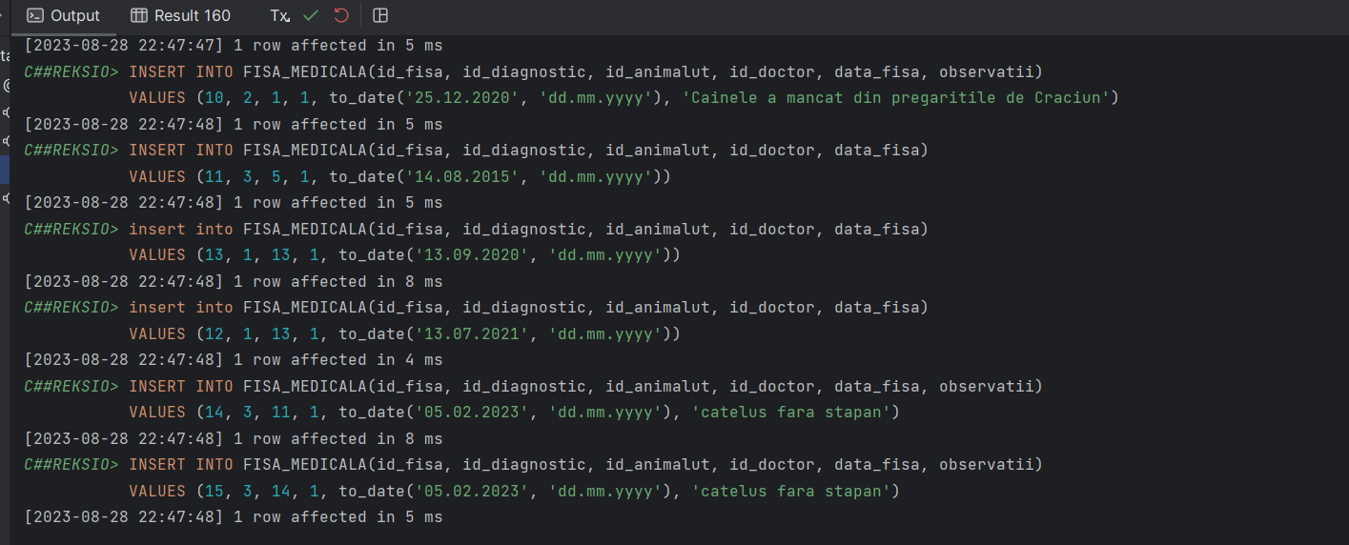

-- 2. criptarea datelor  
drop table ENCKEYS cascade constraints;  
drop table PROPRIETAR_DECRYPTED cascade constraints;  
drop table PROPRIETAR_ENCRYPTED cascade constraints;  
  
  
CREATE TABLE ENCKeys  
(  
 id_key NUMBER(7),  
 enc_key RAW(16),  
 CONSTRAINT pk_ENCKeys PRIMARY KEY (id_key)  
);  
  
CREATE TABLE Proprietar_Encrypted  
(  
 id_proprietar NUMBER(10),  
 nume RAW(100) NOT NULL,  
 prenume RAW(100) NOT NULL,  
 telefon RAW(100) NOT NULL,  
 email RAW(100) NOT NULL,  
 id_locatie RAW(100) NOT NULL,  
 CONSTRAINT pk_proprietar_enc PRIMARY KEY (id_proprietar)  
);  
  
CREATE TABLE Proprietar_Decrypted  
(  
 id_proprietar NUMBER(10),  
 nume VARCHAR2(32) NOT NULL,  
 prenume VARCHAR2(32) NOT NULL,  
 telefon NUMBER(10) NOT NULL,  
 email VARCHAR2(64) NOT NULL,  
 id_locatie NUMBER(10) NOT NULL,  
 CONSTRAINT pk_proprietar_dec PRIMARY KEY (id_proprietar)  
);  
  
CREATE OR REPLACE PROCEDURE *Encrypt_Proprietar* AS  
 encryption_key RAW(16);  
 encryption_binary_location RAW(100);  
 encryption_binary_last_name RAW(100);  
 encryption_binary_first_name RAW(100);  
 encryption_binary_email RAW(100);  
 encryption_binary_phone RAW(100);  
 encryption_type PLS_INTEGER;  
BEGIN  
 FOR c IN (SELECT * FROM PROPRIETAR)  
 LOOP  
 encryption_key := DBMS_CRYPTO.*randombytes*(16);  
  
 INSERT INTO ENCKeys (id_key, enc_key) VALUES (c.id_proprietar, encryption_key);  
  
 encryption_type := DBMS_CRYPTO.ENCRYPT_AES128 + DBMS_CRYPTO.PAD_PKCS5 + DBMS_CRYPTO.CHAIN_CBC;  
  
 encryption_binary_location :=  
 DBMS_CRYPTO.*encrypt*(UTL_I18N.*STRING_TO_RAW*(c.id_locatie, 'AL32UTF8'), encryption_type,  
 encryption_key);  
 encryption_binary_last_name :=  
 DBMS_CRYPTO.*encrypt*(UTL_I18N.*STRING_TO_RAW*(c.prenume, 'AL32UTF8'), encryption_type, encryption_key);  
 encryption_binary_first_name :=  
 DBMS_CRYPTO.*encrypt*(UTL_I18N.*STRING_TO_RAW*(c.nume, 'AL32UTF8'), encryption_type, encryption_key);  
 encryption_binary_email :=  
 DBMS_CRYPTO.*encrypt*(UTL_I18N.*STRING_TO_RAW*(c.email, 'AL32UTF8'), encryption_type, encryption_key);  
 encryption_binary_phone :=  
 DBMS_CRYPTO.*encrypt*(UTL_I18N.*STRING_TO_RAW*(c.telefon, 'AL32UTF8'), encryption_type, encryption_key);  
  
 INSERT INTO PROPRIETAR_Encrypted (id_proprietar,  
 nume, prenume, telefon,  
 email, id_locatie)  
 VALUES (c.id_proprietar, encryption_binary_last_name, encryption_binary_first_name, encryption_binary_phone,  
 encryption_binary_email, encryption_binary_location);  
 END LOOP;  
 COMMIT;  
END ;  
  
BEGIN  
 *Encrypt_Proprietar*();  
end;  
  
SELECT *  
FROM ENCKeys;  
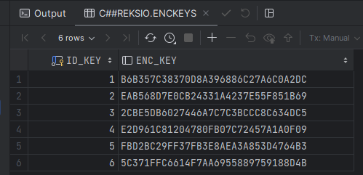  
SELECT *  
FROM PROPRIETAR_ENCRYPTED;  
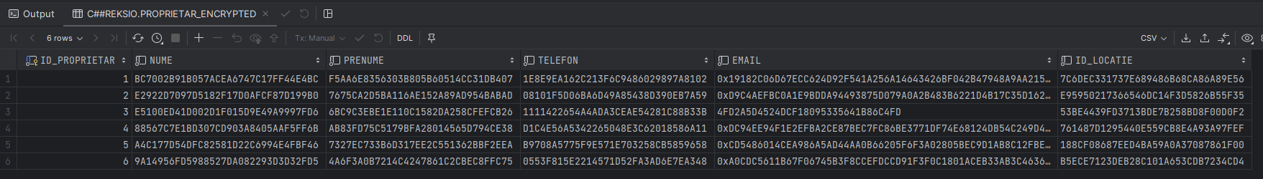  
CREATE OR REPLACE PROCEDURE *Decrypt_Proprietar* AS  
 encryption_type PLS_INTEGER;  
 decryption_key RAW(16);  
 decrypted_location VARCHAR2(100);  
 decrypted_last_name VARCHAR2(100);  
 decrypted_first_name VARCHAR2(100);  
 decrypted_email VARCHAR2(100);  
 decrypted_phone VARCHAR2(100);  
BEGIN  
 FOR c_enc IN (SELECT * FROM PROPRIETAR_ENCRYPTED)  
 LOOP  
  
 SELECT enc_key  
 INTO decryption_key  
 FROM ENCKeys  
 WHERE id_key = *TO_NUMBER*(c_enc.id_proprietar);  
  
 encryption_type := DBMS_CRYPTO.ENCRYPT_AES128 + DBMS_CRYPTO.PAD_PKCS5 + DBMS_CRYPTO.CHAIN_CBC;  
  
 decrypted_location :=  
 UTL_I18N.*RAW_TO_CHAR*(DBMS_CRYPTO.*DECRYPT*(c_enc.id_locatie, encryption_type, decryption_key));  
 decrypted_last_name :=  
 UTL_I18N.*RAW_TO_CHAR*(DBMS_CRYPTO.*DECRYPT*(c_enc.nume, encryption_type, decryption_key));  
 decrypted_first_name :=  
 UTL_I18N.*RAW_TO_CHAR*(DBMS_CRYPTO.*DECRYPT*(c_enc.prenume, encryption_type, decryption_key));  
 decrypted_email := UTL_I18N.*RAW_TO_CHAR*(DBMS_CRYPTO.*DECRYPT*(c_enc.email, encryption_type, decryption_key));  
 decrypted_phone :=  
 UTL_I18N.*RAW_TO_CHAR*(DBMS_CRYPTO.*DECRYPT*(c_enc.telefon, encryption_type, decryption_key));  
  
 INSERT INTO PROPRIETAR_DECRYPTED (id_proprietar, nume, prenume, telefon, email, id_locatie)  
 VALUES (c_enc.id_proprietar,  
 decrypted_first_name,  
 decrypted_last_name,  
 decrypted_phone, decrypted_email,  
 decrypted_location);  
 END LOOP;  
 COMMIT;  
END;  
  
BEGIN  
 *DECRYPT_PROPRIETAR*();  
end;  
  
SELECT *  
FROM PROPRIETAR_DECRYPTED;  
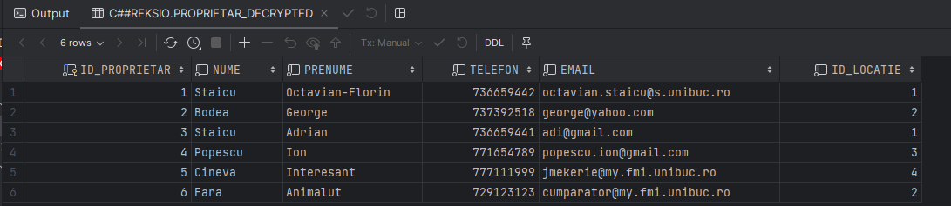  
-- 3. Auditarea  
  
ALTER SYSTEM SET audit_trail = db, extended SCOPE = spfile;  
  
AUDIT SELECT, UPDATE, INSERT, DELETE ON FISA_MEDICALA;  
  
CREATE SYNONYM AUD$ FOR SYS.AUD$;  
  
SELECT *  
FROM FISA_MEDICALA;  
  
INSERT INTO FISA_MEDICALA(id_fisa, id_diagnostic, id_animalut, id_doctor, data_fisa, observatii)  
VALUES (1113, 1, 1, 1, *sysdate*, 'obs audit');  
  
SELECT obj$name, sqltext, userid  
from AUD$  
ORDER BY ntimestamp# DESC;  
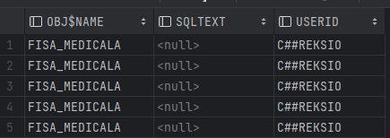  
-- b)  
  
CREATE SEQUENCE secv_audit START WITH 1 INCREMENT BY 1;  
  
CREATE TABLE audit_fisa_medicala  
(  
 sec_id NUMBER(4) PRIMARY KEY,  
 user_name VARCHAR2(20) NOT NULL,  
 session_name VARCHAR2(20) NOT NULL,  
 data_modificare DATE NOT NULL,  
 observatii_vechi VARCHAR2(4000) NOT NULL,  
 observatii_noi VARCHAR2(4000) NOT NULL  
);  
  
CREATE OR REPLACE TRIGGER trigger_audit_fisa_medicala  
 AFTER INSERT OR UPDATE OF observatii  
 ON FISA_MEDICALA  
 FOR EACH ROW  
 WHEN (NEW.observatii IS NOT NULL and OLD.observatii IS NOT NULL )  
BEGIN  
 DECLARE  
 v_old_observatii FISA_MEDICALA.observatii%TYPE := :OLD.observatii;  
 v_new_observatii FISA_MEDICALA.observatii%TYPE := :NEW.observatii;  
 BEGIN  
 INSERT INTO audit_fisa_medicala(sec_id, user_name, session_name, data_modificare, observatii_vechi,  
 observatii_noi)  
 VALUES (secv_audit.NEXTVAL, *sys_context*('userenv', 'session_user'), *sys_context*('userenv', 'host'), *sysdate*,  
 v_old_observatii, v_new_observatii);  
 END;  
END;  
/  
  
UPDATE FISA_MEDICALA  
set observatii = 'obs audit 2'  
where id_fisa = 1113;  
  
SELECT *  
FROM audit_fisa_medicala;   
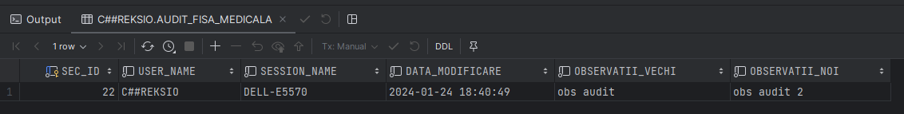

-- c)  
-- GRANT EXECUTE ON DBMS_FGA TO C##REKSIO;  
  
  
CREATE OR REPLACE PROCEDURE *POLICY_HANDLER_FISA_MEDICALA*(object_schema VARCHAR2, object_name VARCHAR2, policy_name VARCHAR2)  
AS  
BEGIN  
 DBMS_OUTPUT.*PUT_LINE*('Audit Policy: [object_schema = ' || object_schema || ']; [object_name = ' || object_name ||  
 ']; [policy_name = ' || policy_name || ']');  
END;  
/  
  
-- GRANT SELECT ON DBA_FGA_AUDIT_TRAIL TO c##reksio;  
CREATE OR REPLACE PROCEDURE *CREATE_AUDIT_POLICY_FOR_FISA_MEDICALA* as  
BEGIN  
  
 BEGIN  
 dbms_fga.*drop_policy*(  
 object_schema => 'C##REKSIO',  
 object_name => 'FISA_MEDICALA',  
 policy_name => 'POLICY_FISA_MEDICALA'  
 );  
 EXCEPTION  
 WHEN OTHERS then  
 NULL;  
 END;  
 dbms_fga.*add_policy*(  
 object_schema => 'C##REKSIO',  
 object_name => 'FISA_MEDICALA',  
 policy_name => 'POLICY_FISA_MEDICALA',  
 enable => false,  
 statement_types => 'UPDATE',  
 handler_module => 'POLICY_HANDLER_FISA_MEDICALA');  
END;  
/  
  
  
BEGIN  
 *CREATE_AUDIT_POLICY_FOR_FISA_MEDICALA*();  
 dbms_fga.*enable_policy*(object_schema => 'C##REKSIO',  
 object_name => 'FISA_MEDICALA',  
 policy_name => 'POLICY_FISA_MEDICALA');  
END;  
  
UPDATE FISA_MEDICALA  
set observatii = 'obs audit 3'  
where id_fisa = 1113;  
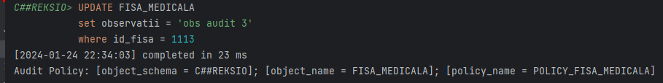

SELECT *  
FROM dba_fga_audit_trail  
ORDER BY TIMESTAMP DESC;



  
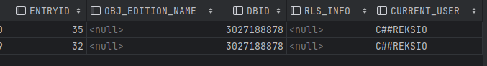

DELETE  
FROM FISA_MEDICALA  
where id_fisa = 1113;  
commit;

Utilizatorii:

* Administrator
* Doctor
* Contabil
* Guest

Procesele:

* P1: Diagnosticare animalut
* P2: Inregistrare factura/plata
* P3: Adaugare/alterare utilizator
* P4: Inventar
* P5: editare/stergere date (gresite sau la cererea clientilor etc)

Cele 3 matrici:

1. Proces-utilizator

|  |  |  |  |  |  |
| --- | --- | --- | --- | --- | --- |
|  | **P1** | **P2** | **P3** | **P4** | **P5** |
| **Administrator** |  |  | X |  | X |
| **Doctor** | X |  |  |  |  |
| **Contabil** |  | X |  | X |  |
| **Guest** |  |  |  |  |  |

1. Entitate-proces

|  |  |  |  |  |  |
| --- | --- | --- | --- | --- | --- |
|  | P1 | P2 | P3 | P4 | P5 |
| PROPRIETAR |  | S,U,I,D |  |  | U,D |
| ANIMALUT | S,U,I,D |  |  |  | U,D |
| DIAGNOSTIC | S,U,I,D |  |  |  | U,D |
| FACTURA |  | S,U,I,D |  |  | U,D |
| CHITANTA |  | S,U,I,D |  |  | U,D |
| FACTURA_PROPRIETAR |  | S,U,I,D |  |  | U,D |
| FACTURA_PRODUCATOR |  | S,U,I,D |  |  | U,D |
| INVENTAR |  |  |  | S,U,I | U,D |
| PRODUSE_DIN_INVENTAR |  |  |  | S,U,I | U,D |
| PRODUS |  | S,U,I,D |  | S,U,I | U,D |
| FISA_MEDICALA | S,U,I,D | S |  |  | U,D |
| ANGAJAT | S |  | S,U,I,D |  | U,D |
| CONTRACT |  |  | S,U,I,D | S | U,D |
| CONTRACT_PRODUCATOR |  |  |  | S | U,D |
| CONTRACT_ANGAJAT |  |  | S,U,I,D |  | U,D |
| PRODUCATOR |  | S,U,I,D |  | S | U,D |
| LOCATIE |  | S,U,I,D |  | S | U,D |

1. Entitate-utilizator

|  |  |  |  |  |  |
| --- | --- | --- | --- | --- | --- |
|  | Administrator | Doctor | Contabil | Guest_Doctor | Guest_Finante |
| PROPRIETAR | S,U,D | S,U,I | S,U,I | S |  |
| ANIMALUT | S,U,D | S,U,I | S | S |  |
| DIAGNOSTIC | S,U,D | S,U,I,D |  | S |  |
| FACTURA | S,U,D | S | S,U,I | S | S |
| CHITANTA | S,U,D |  | S,U,I |  | S |
| FACTURA_PROPRIETAR | S,U,D | S | S,U,I | S | S |
| FACTURA_PRODUCATOR | S,U,D |  | S,U,I |  | S |
| INVENTAR | S,U,D | S | S,U,I |  | S |
| PRODUSE_DIN_INVENTAR | S,U,D | S | S,U,I |  | S |
| PRODUS | S,U,D | S | S,U,I |  | S |
| FISA_MEDICALA | S,U,D | S,U,I | S | S |  |
| ANGAJAT | S,I,U,D | S | S | S | S |
| CONTRACT | S,I,U,D |  | S |  |  |
| CONTRACT_PRODUCATOR | S,I,U,D |  | S |  |  |
| CONTRACT_ANGAJAT | S,I,U,D |  | S |  |  |
| PRODUCATOR | S,U,D | S | S,U,I,D |  | S |
| LOCATIE | S,U,D | S,I,U | S,I,U | S | S |

-- 4. gestionarea utilizatorilor unei baze de date si a resurseloc computationale  
CREATE USER C##ADMINISTRATOR IDENTIFIED BY PASSWORD PASSWORD EXPIRE;  
GRANT CREATE SESSION TO C##ADMINISTRATOR;  
  
CREATE USER C##DOCTOR IDENTIFIED BY PASSWORD PASSWORD EXPIRE;  
GRANT CREATE SESSION TO C##DOCTOR;  
  
CREATE USER C##CONTABIL IDENTIFIED BY PASSWORD PASSWORD EXPIRE;  
GRANT CREATE SESSION TO C##CONTABIL;  
  
CREATE USER C##GUEST_DOCTOR IDENTIFIED BY PASSWORD PASSWORD EXPIRE;  
GRANT CREATE SESSION TO C##GUEST_DOCTOR;  
  
CREATE USER C##GUEST_FINANTE IDENTIFIED BY PASSWORD PASSWORD EXPIRE;  
GRANT CREATE SESSION TO C##GUEST_FINANTE;  
  
ALTER USER C##ADMINISTRATOR QUOTA UNLIMITED ON USERS;  
ALTER USER C##DOCTOR QUOTA UNLIMITED ON USERS;  
ALTER USER C##CONTABIL QUOTA UNLIMITED ON USERS;  
ALTER USER C##GUEST_DOCTOR QUOTA 1M ON USERS;  
ALTER USER C##GUEST_FINANTE QUOTA 1M ON USERS;  
  
-- GRANT SELECT ON DBA_TS_QUOTAS to c##reksio;  
SELECT *  
FROM DBA_TS_QUOTAS  
where TABLESPACE_NAME='USERS';

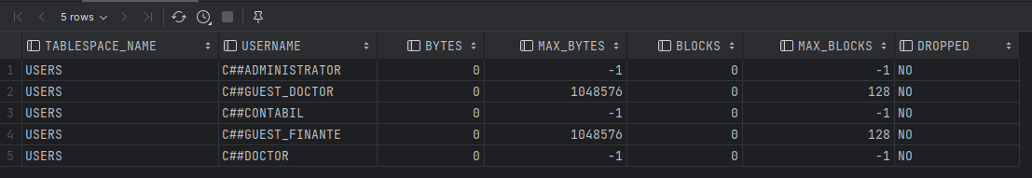

CREATE PROFILE C##FULL_PROFILE LIMIT  
 SESSIONS_PER_USER 5  
 IDLE_TIME 20  
 FAILED_LOGIN_ATTEMPTS 4  
 CONNECT_TIME 120;  
  
CREATE PROFILE C##GUEST_PROFILE LIMIT  
 SESSIONS_PER_USER 20  
 IDLE_TIME 5  
 FAILED_LOGIN_ATTEMPTS 10  
 CONNECT_TIME 10;  
  
ALTER USER C##ADMINISTRATOR PROFILE C##FULL_PROFILE;  
ALTER USER C##DOCTOR PROFILE C##FULL_PROFILE;  
ALTER USER C##CONTABIL PROFILE C##FULL_PROFILE;  
ALTER USER C##GUEST_DOCTOR PROFILE C##GUEST_PROFILE;  
ALTER USER C##GUEST_FINANTE PROFILE C##GUEST_PROFILE;

SELECT *  
FROM DBA_USERS  
WHERE *UPPER*(USERNAME) LIKE 'C##%';  
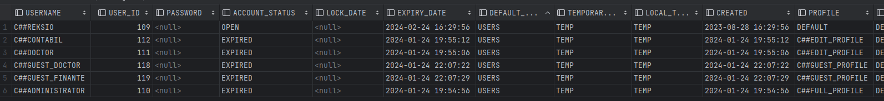

-- 5. Privilegii si roluri  
CREATE ROLE C##ADMIN_ROLE;  
GRANT SELECT, UPDATE, DELETE ON PROPRIETAR TO C##ADMIN_ROLE;  
GRANT SELECT, UPDATE, DELETE ON ANIMALUT TO C##ADMIN_ROLE;  
GRANT SELECT, UPDATE, DELETE ON DIAGNOSTIC TO C##ADMIN_ROLE;  
GRANT SELECT, UPDATE, DELETE ON FACTURA TO C##ADMIN_ROLE;  
GRANT SELECT, UPDATE, DELETE ON CHITANTA TO C##ADMIN_ROLE;  
GRANT SELECT, UPDATE, DELETE ON FACTURA_PROPRIETAR TO C##ADMIN_ROLE;  
GRANT SELECT, UPDATE, DELETE ON FACTURA_PRODUCATOR TO C##ADMIN_ROLE;  
GRANT SELECT, UPDATE, DELETE ON INVENTAR TO C##ADMIN_ROLE;  
GRANT SELECT, UPDATE, DELETE ON PRODUSE_DIN_INVENTAR TO C##ADMIN_ROLE;  
GRANT SELECT, UPDATE, DELETE ON PRODUS TO C##ADMIN_ROLE;  
GRANT SELECT, UPDATE, DELETE ON FISA_MEDICALA TO C##ADMIN_ROLE;  
GRANT SELECT, UPDATE, DELETE ON PRODUCATOR TO C##ADMIN_ROLE;  
GRANT SELECT, UPDATE, DELETE ON LOCATIE TO C##ADMIN_ROLE;  
GRANT SELECT, INSERT, UPDATE, DELETE ON ANGAJAT TO C##ADMIN_ROLE;  
GRANT SELECT, INSERT, UPDATE, DELETE ON CONTRACT TO C##ADMIN_ROLE;  
GRANT SELECT, INSERT, UPDATE, DELETE ON CONTRACT_ANGAJAT TO C##ADMIN_ROLE;  
GRANT SELECT, INSERT, UPDATE, DELETE ON CONTRACT_PRODUCATOR TO C##ADMIN_ROLE;  
  
CREATE ROLE C##DOCTOR_ROLE;  
GRANT SELECT, INSERT, UPDATE on PROPRIETAR to C##DOCTOR_ROLE;  
GRANT SELECT, INSERT, UPDATE on ANIMALUT to C##DOCTOR_ROLE;  
GRANT SELECT, INSERT, UPDATE, DELETE on DIAGNOSTIC to C##DOCTOR_ROLE;  
GRANT SELECT on INVENTAR to C##DOCTOR_ROLE;  
GRANT SELECT on PRODUSE_DIN_INVENTAR to C##DOCTOR_ROLE;  
GRANT SELECT on PRODUS to C##DOCTOR_ROLE;  
GRANT SELECT, INSERT, UPDATE on FISA_MEDICALA to C##DOCTOR_ROLE;  
GRANT SELECT on ANGAJAT to C##DOCTOR_ROLE;  
GRANT SELECT on PRODUCATOR to C##DOCTOR_ROLE;  
GRANT SELECT, INSERT, UPDATE on LOCATIE to C##DOCTOR_ROLE;  
GRANT SELECT on FACTURA to C##DOCTOR_ROLE;  
GRANT SELECT on FACTURA_PROPRIETAR to C##DOCTOR_ROLE;  
  
CREATE ROLE C##FINANCE_ROLE;  
GRANT SELECT, INSERT, UPDATE on PROPRIETAR to C##FINANCE_ROLE;  
GRANT SELECT on ANIMALUT to C##FINANCE_ROLE;  
GRANT SELECT, INSERT, UPDATE on FACTURA to C##FINANCE_ROLE;  
GRANT SELECT, INSERT, UPDATE on CHITANTA to C##FINANCE_ROLE;  
GRANT SELECT, INSERT, UPDATE on FACTURA_PROPRIETAR to C##FINANCE_ROLE;  
GRANT SELECT, INSERT, UPDATE on FACTURA_PRODUCATOR to C##FINANCE_ROLE;  
GRANT SELECT, INSERT, UPDATE on INVENTAR to C##FINANCE_ROLE;  
GRANT SELECT, INSERT, UPDATE on PRODUSE_DIN_INVENTAR to C##FINANCE_ROLE;  
GRANT SELECT, INSERT, UPDATE on PRODUS to C##FINANCE_ROLE;  
GRANT SELECT on FISA_MEDICALA to C##FINANCE_ROLE;  
GRANT SELECT on ANGAJAT to C##FINANCE_ROLE;  
GRANT SELECT on CONTRACT to C##FINANCE_ROLE;  
GRANT SELECT on CONTRACT_PRODUCATOR to C##FINANCE_ROLE;  
GRANT SELECT on CONTRACT_ANGAJAT to C##FINANCE_ROLE;  
GRANT SELECT, INSERT, UPDATE,DELETE on PRODUCATOR to C##FINANCE_ROLE;  
GRANT SELECT, INSERT, UPDATE on LOCATIE to C##FINANCE_ROLE;  
  
CREATE ROLE C##GUEST_DOCTOR_ROLE;  
GRANT SELECT on PROPRIETAR to C##GUEST_DOCTOR_ROLE;  
GRANT SELECT on ANIMALUT to C##GUEST_DOCTOR_ROLE;  
GRANT SELECT on DIAGNOSTIC to C##GUEST_DOCTOR_ROLE;  
GRANT SELECT on FACTURA to C##GUEST_DOCTOR_ROLE;  
GRANT SELECT on FACTURA_PROPRIETAR to C##GUEST_DOCTOR_ROLE;  
GRANT SELECT on FISA_MEDICALA to C##GUEST_DOCTOR_ROLE;  
GRANT SELECT on ANGAJAT to C##GUEST_DOCTOR_ROLE;  
GRANT SELECT on LOCATIE to C##GUEST_DOCTOR_ROLE;  
  
CREATE ROLE C##GUEST_FINANCE_ROLE;  
GRANT SELECT on FACTURA to C##GUEST_FINANCE_ROLE;  
GRANT SELECT on CHITANTA to C##GUEST_FINANCE_ROLE;  
GRANT SELECT on FACTURA_PROPRIETAR to C##GUEST_FINANCE_ROLE;  
GRANT SELECT on FACTURA_PRODUCATOR to C##GUEST_FINANCE_ROLE;  
GRANT SELECT on INVENTAR to C##GUEST_FINANCE_ROLE;  
GRANT SELECT on PRODUSE_DIN_INVENTAR to C##GUEST_FINANCE_ROLE;  
GRANT SELECT on PRODUS to C##GUEST_FINANCE_ROLE;  
GRANT SELECT on ANGAJAT to C##GUEST_FINANCE_ROLE;  
GRANT SELECT on PRODUCATOR to C##GUEST_FINANCE_ROLE;  
GRANT SELECT on LOCATIE to C##GUEST_FINANCE_ROLE;  
  
GRANT C##ADMIN_ROLE to C##ADMINISTRATOR;  
GRANT C##DOCTOR_ROLE to C##DOCTOR;  
GRANT C##FINANCE_ROLE to C##CONTABIL;  
GRANT C##GUEST_DOCTOR_ROLE to C##GUEST_DOCTOR;  
GRANT C##GUEST_FINANCE_ROLE to C##GUEST_FINANTE;

-- 6. contextul aplicatiei  
  
CREATE OR REPLACE PROCEDURE *CONTEXT_TURA_ZI_NOAPTE* IS  
 curr_hour NUMBER(3);  
BEGIN  
 SELECT *TO_NUMBER*(*TO_CHAR*(*sysdate*, 'hh24'))  
 INTO curr_hour  
 FROM dual;  
  
 DBMS_OUTPUT.*PUT_LINE*('THE HOUR IS: '|| curr_hour);  
  
 IF curr_hour < 10 OR curr_hour > 20 THEN  
 DBMS_OUTPUT.*PUT_LINE*('Se lucreaza in tura de noapte! Atentie la datele introduse!');  
 DBMS_SESSION.*SET_CONTEXT*('APP_CONTEXT', 'ACC_NIGHT_SHIFT', 'YES');  
 ELSE  
 dbms_session.*set_context*('APP_CONTEXT', 'ACC_NIGHT_SHIFT', 'NO');  
 END IF;  
END;  
/  
  
CREATE CONTEXT APP_CONTEXT USING CONTEXT_TURA_ZI_NOAPTE;  
  
BEGIN  
 *CONTEXT_TURA_ZI_NOAPTE*();  
end;  
  
CREATE OR REPLACE TRIGGER TRIGGER_ACCESS  
 AFTER LOGON ON DATABASE  
DECLARE  
BEGIN  
 *CONTEXT_TURA_ZI_NOAPTE*();  
END;  
/  
  
DECLARE  
 night_shift_value VARCHAR2(3);  
BEGIN  
 SELECT *SYS_CONTEXT*('APP_CONTEXT','ACC_NIGHT_SHIFT') INTO night_shift_value  
 FROM dual;  
  
 DBMS_OUTPUT.*PUT_LINE*('Night Shift Value: ' || night_shift_value);  
  
end;

